To: coreteam@officegreen.com.
Subject: [important] Plant Pals - Team meeting - July 21st / 10:00 AM / CONFERENCE ROOM
Opening:
Greeting everyone, I want to start with a word of appreciation to everyone, what a great job you are all doing so far, we made a huge progress over the past months.
Body:
After 4 weeks of pre-launch deliveries, we surveyed 50 of our clients on a few topics we wanted to know their opinion on. And with the data collected, we have taken some action after week 2 which improved our situation a bit, but we need to discuss these topics further, find more ways to improve them, and come up with a plan during a brainstorm session.
Closing:
I would really appreciate it if everyone will attend the meeting and be as engaging and active as possible, so we can be as productive as possible as a team. To help you be better prepared in advance for this meeting, I attached to this email a link to the Meeting Agenda which includes the topics we are going to discuss.
Thank you everyone, and I hope to see you all soon.
Signature: Name, Project Manager

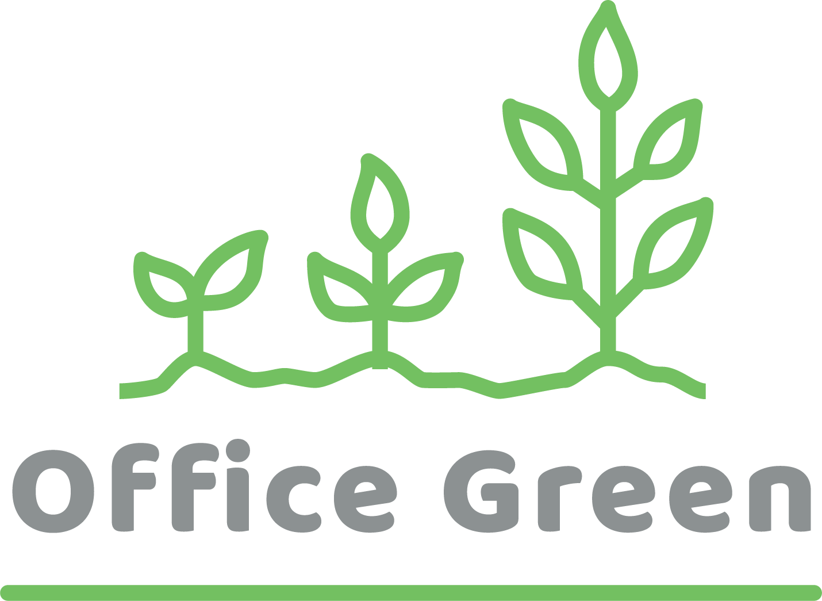

Attachments: Meeting Agenda Link

